## SANKALCHAND PATEL UNIVERSITY

VISNAGAR



Sankalchand Patel College of Engineering

A Report On

**NFT Marketplace**

Under subject of Mini Project-I (1ET1000501)

B. Tech (Computer) Sem: V

Submitted by: Group:

|  |  |  |
| --- | --- | --- |
| Sr. | Name of student | PRN |
| 1. | Vohra Mohammad | 2020095900011033 |
| 2. | Yukta Patel | 2020095900009726 |
| 3. | Brinda Prajapati | 2020095900010447 |

Prof.Rupal R.Chaudhari

(Faculty Guide)

Dr. Kirit J. Modi (Head of Department)

Academic year (2022-23)

# CANDIDATE’S DECLARATION

We hereby declare that the work presented in this project entitled **“NFT Marketplace”**submitted towards completion of project in **Fifth Semester** of B. Tech (IT) is an authentic record of our original work carried out under the guidance of “**Prof. Rupal R.Chaudhari”**. We have not submitted the matter embodied in this project for the award of any other degree.

### Semester: 5th

**Place: Sankalchand Patel College of Engineering, Visnagar**

### Signature:

### Vohra Mohammad: 2020095900011033

### Yukta Patel : 2020095900009726

### Brinda Prajapati : 2020095900010447



# CERTIFICATE

Date:

This is to certify that the **“NFT Marketplace”** has been carried out by **Yukta patel** under my guidance in fulfilment of the subject Mini Project-I in IT engineering (5thSemester) of Sankalchand Patel University, Visnagar during the academic year 2022-23.

|  |  |
| --- | --- |
| Prof. Rupal R.Chaudhari | Dr. Kirit J. Modi |
| **(Internal Guide)** | **(Head of the Department)** |



# CERTIFICATE

Date:

This is to certify that the **“NFT Marketplace”** has been carried out by  **Brinda Prajapati** under my guidance in fulfilment of the subject Mini Project-I in IT Engineering (5thSemester) of Sankalchand Patel University, Visnagar during the academic year 2022- 23.

|  |  |
| --- | --- |
| Prof. Rupal R.Chaudhari | Dr. Kirit J. Modi |
| **(Internal Guide)** | **(Head of the Department)** |

# ACKNOWLEDGEMENT

We have taken many efforts in this project. However, it would not have been possible without the kind support and help of many individuals and organizations. We would like to extend our sincere thanks to all of them.

We are highly indebted to **Prof. Rupal R.Chaudhari** for their guidance and constant supervision as well as for providing necessary information regarding the Mini Project Titled

**“NFT Marketplace”.** We would like to express our gratitude towards staff members of Computer and IT Engineering Department, Sankalchand Patel College of Engineering for their kind co- operation and encouragement which helped us in completion of this project.

We even thank and appreciate to our colleague in developing the project and people who have willingly helped us out with their abilities.

Vohra Mohammad: 2020095900016927

Yukta Patel : 2020095900016951

Brinda Prajapati : 2020095900011064

# ABSTRACT

# 

⮚An NFT marketplace is **a blockchain-based online platform to sell and buy non-fungible tokens (NFTs)**. Despite the short-term fluctuations in the quickly developing NFT field, the global NFT market is expected to grow from $3.0 billion in 2022 to $13.6 billion by 2027.NFTs are also called non-fungible tokens, and they are **blockchain-held tokens that represent a unique asset – whether physical or digital**. NFTs are secured on cryptocurrency blockchains, trading using Ethereum, Solana, Wax and other tokens

## How Is an NFT Different From Cryptocurrency?

NFT stands for non-fungible token. It’s generally built using the same kind of programming as cryptocurrency, like BItcoin or EThereum, but that’s where the similarity ends.

Physical money and cryptocurrencies are “fungible,” meaning they can be traded or exchanged for one another. They’re also equal in value—one dollar is always worth another dollar; one Bitcoin is always equal to another Bitcoin. Crypto’s fungibility makes it a trusted means of conducting transactions on the blockchain.

NFTs are different. Each has a digital signature that makes it impossible for NFTs to be exchanged for or equal to one another (hence, non-fungible). One NBA Top Shot clip, for example, is not equal to EVERYDAYS simply because they’re both NFTs. (One NBA Top Shot clip isn’t even necessarily equal to another NBA Top Shot clip, for that matter.)

Contents

Chapter 1: Introduction 8

Information NFT Marketplace 9

Background 10

Blockchain 10

Methodology Error! Bookmark not defined.

Chapter 2: Technology 12

Software Requirements 13

Hardware Requirements 13

Chapter 3: Introduction to Smart Contract 15

Introduction 16

Chapter 4: Ethereum and Metamask 19

[Role of Ethereum 17](#_bookmark13)

[Role Of Metamask Wallet 18](#_bookmark13)

Chapter 5: Snapshots 22

Reference0 23

SANKALCHAND PATEL COLLEGE OF ENGINEERING, VISNAGAR

# 

# Chapter 1: Introduction

**Why do You Need an NFT Marketplace?**

It is quite clear that [blockchain technology](https://101blockchains.com/blockchain-technology-explained/) and NFTs can offer the perfect opportunity for artists and content creators to obtain financial remuneration for their works. Now, artists don’t have to depend anymore on auction houses or galleries for selling their artwork. On the contrary, an artist could just sell their work to a buyer in the form of NFT. This also helps the artists in getting a better share of the profits.

Interestingly, NFTs also involve the scope for royalties that entitle the original creator to a certain percentage of subsequent sales of the artwork. Many people interested in finding out the top NFT marketplace would become eager to find out how they can start an NFT collection. Interested buyers might be looking for ways to buy NFTs. So, let us take a look into the things that go into making NFTs available for selling and buying –

1. You need a digital wallet for storing NFTs and cryptocurrency to pay for transactions on your selected blockchain platform.
2. Purchase cryptocurrency, possibly [Ether](https://101blockchains.com/what-is-ether/), or the currency supported on your selected NFT provider.
3. It is possible to buy crypto through credit cards on different platforms such as PayPal, Coinbase Wallet, eToro, and Kraken.
4. Users could move cryptocurrency from exchanges to their preferred wallets.

## Background

#### Blockchain:

The Blockchain Structure is also known as an append-only data structure, such that new blocks of data can be written to it but cannot be altered or deleted. Private blockchain limits the read and write access, only specific participants can verify their transactions internally. That makes the transaction on a private network cheaper, since they only need to be verified by a few nodes that are trusted and with guaranteed high processing power. Nodes are very well connected, and faults can quickly be fixed by manual intervention, allowing the use of consensus algorithms which offer finality after much shorter block times. In our Research we will use Permissioned Blockchain which will use the Proof of Authority (POA) consensus Algorithm, A Consensus Algorithm is used to set restrictions on selected known entities to certify and validate Transactions on Blockchain.

The first things that come to mind about the blockchain are cryptocurrencies and contracts because of the well-known initiatives in Bitcoin and Ethereum. Bitcoin was the first crypto-currency solution that used a blockchain data structure. Ethereum introduced smart contracts that leverage the power of blockchain immutability and distributed consensus while offering a crypto currency solution comparable to Bitcoin.

The concept of smart contracts was introduced much earlier by Nick Szabo in the 1990s and is described as “a set of promises, specified in digital form, including protocols within which the parties perform on these promises”. In Ethereum, a smart contract is a piece of code deployed to the network so that everyone has access to it. The result of executing this code is verified by a consensus mechanism and by every

member of the network. Today, we call a blockchain a set of technologies combining the blockchain data structure itself, distributed consensus algorithm, public key cryptography, and smart contracts. Below we describe these technologies in more detail.

blockchain technology has its drawbacks. Unlike other distributed solutions, a blockchain is hard to scale: An increasing number of nodes does not improve network performance because, by definition, every node needs to execute all transactions, and this process is not shared among the nodes. Moreover, increasing the number of validators impacts performance because it implies a more intensive exchange of messages during consensus. For the same reason, blockchain solutions are vulnerable to various denial-of-service attacks. If a blockchain allows anyone to publish smart contracts in a network, then the operation of the entire network can be disabled by simply putting an infinite loop in a smart contract.

A network can also be attacked by merely sending a considerable number of transactions: At some point, the system will refuse to receive anything else. In cryptocurrency solutions, all transactions have an execution cost: the more resources a transaction utilizes, the more expensive it will be, and there is a cost

threshold, with transactions exceeding the threshold being discarded. In private blockchain networks this problem is solved depending on how the network is implemented via the exact mechanism of transaction cost, access control, or something more suited to the specific context.

# 

# Chapter 2: Technology

## Software Requirements:

* Back End: Solidity
* Operating System: Windows 10 or higher
* Development Tool: Ethereum Virtual Machine, Replit, MetaMask wallet

## Hardware Requirements:

* Processor: I3 processor system or higher
* Hard disk: 4 GB RAM or higher
* RAM: 100 GB ROM or higher

# 

# Chapter 3:

**Introduction to Smart Contract**

## Introduction

The smart contract is the most prominent feature on Ethereum. It is written in the Solidity language that was introduced by Vitalik with a combination of C++ and JavaScript. The smart contract is provided in the Ethereum network that enables it to execute without a traditional server but runs through Ethereum virtual machine. Like the process of Java Code, a smart contract written in Solidity language will run through an Ethereum virtual machine and be translated to Application binary interface (ABI) and Smart Contract Bytecode. The former is used to interact with solidity and bytecode, and the bytecode is packed with other parameters into a transaction. The transaction will be signed and be put on an Ethereum block once deployed. Below is the flowchart of how smart contract deployed on the Ethereum blockchain.

**How Smart contract works ?**

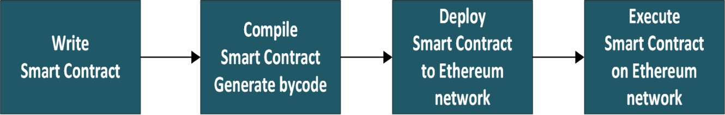

## 

## Chapter 4: Ethereum and Metamask

## Role of Ethereum

Ethereum is a decentralized platform that runs smart contracts: applications that run exactly as programmed without any possibility of fraud or third-party interference. Ethereum is used as a decentralized lottery system because it is secure and tamper-proof. The smart contracts that run on the Ethereum blockchain cannot be altered, making it impossible for anyone to rig the lottery. Ethereum is also transparent, meaning that all transactions are public and can be verified. This makes it impossible for anyone to cheat the system. The lottery industry is worth billions of dollars, and Ethereum provides a secure and tamper-proof way to run a lottery. This makes Ethereum an important part of the lottery industry.

## 

## Metamask Wallet:

⮚MetaMask wallet is a versatile product in the marketplace, **supporting multiple protocols across blockchains**. In addition to supporting over 670,000 coins on the Ethereum ERC-20 protocol, users can also store non-fungible tokens (NFTs) in the wallet and connect them with marketplaces like OpenSea.

**How does MetaMask work?**

⮚Smart contracts are the heart and soul of blockchain transactions. These are self-executing contracts whose agreement terms are written into lines of code on the blockchain. But to run a blockchain, computers in the system (called nodes) have to manage transactions and share information about those transactions with the rest of the network. Rather than run as a node, which can be costly and difficult to maintain, MetaMask operates by running smart contracts on an existing node called Infura. This enables MetaMask to plug into the network.

MetaMask has several functions, the first being its ability to store crypto. You can use it to buy and sell Ether (ETH), the Ethereum blockchain’s primary crypto token, and also to store any Ethereum-compatible token (like ERC-20, and ERC-721). Another function is trading. Users can enact peer-to-peer token swaps with the wallet without the need for an intermediary. To ensure its users are getting the lowest pricing possible, MetaMask uses info from decentralized exchange aggregators. The wallet also lets you connect to the BNB Smart Chain, access other decentralized apps that use the Ethereum network, and play blockchain-based games.

# 

# Chapter 5: Snapshots

**How NFT Marketplace works ?**

⮚Let’s check out our marketplace :

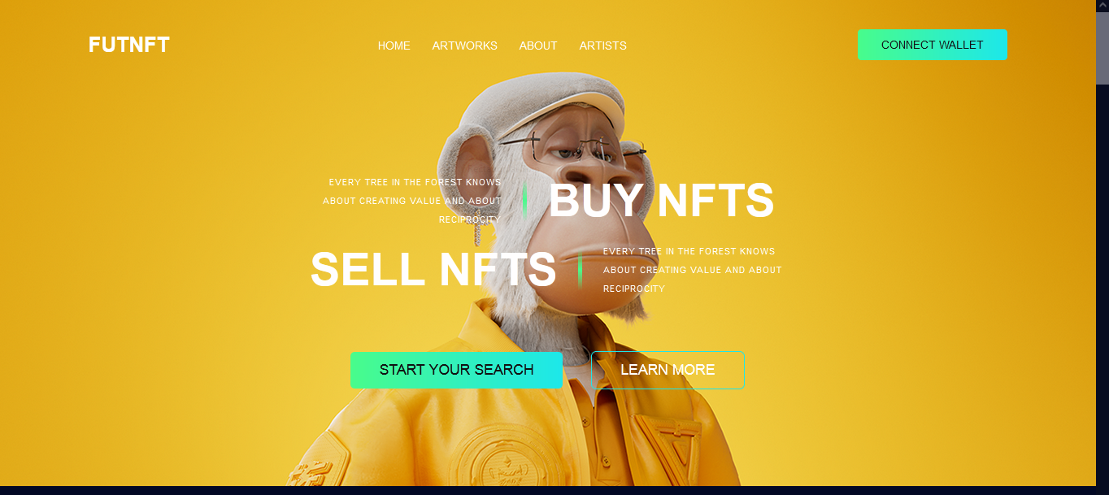

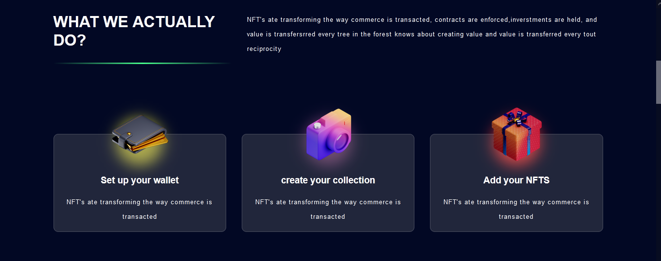

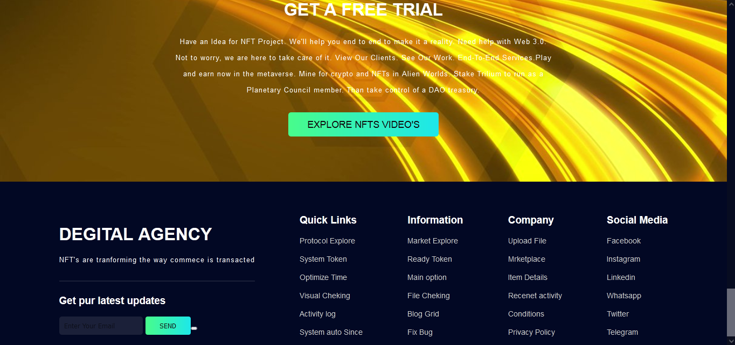

⮚At the home page we can access features shown in above picture.

⮚There are multiple types of filter in search area where you can search different types of nfts and artworks.

⮚There is one option named connect wallet.

⮚When we click thay button this will redirect to the wallet connecting page.

⮚For using that we have to use Metamask. Firstly we have to make one account on Metamask and then we have to connect it to our website.

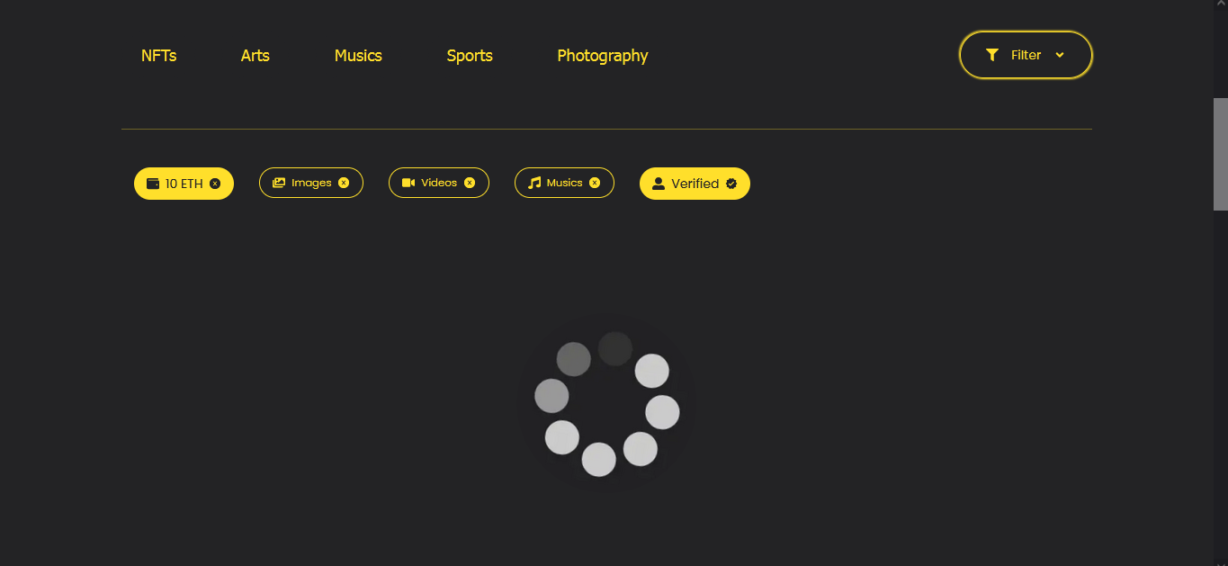

**⮚Create NFT option :**

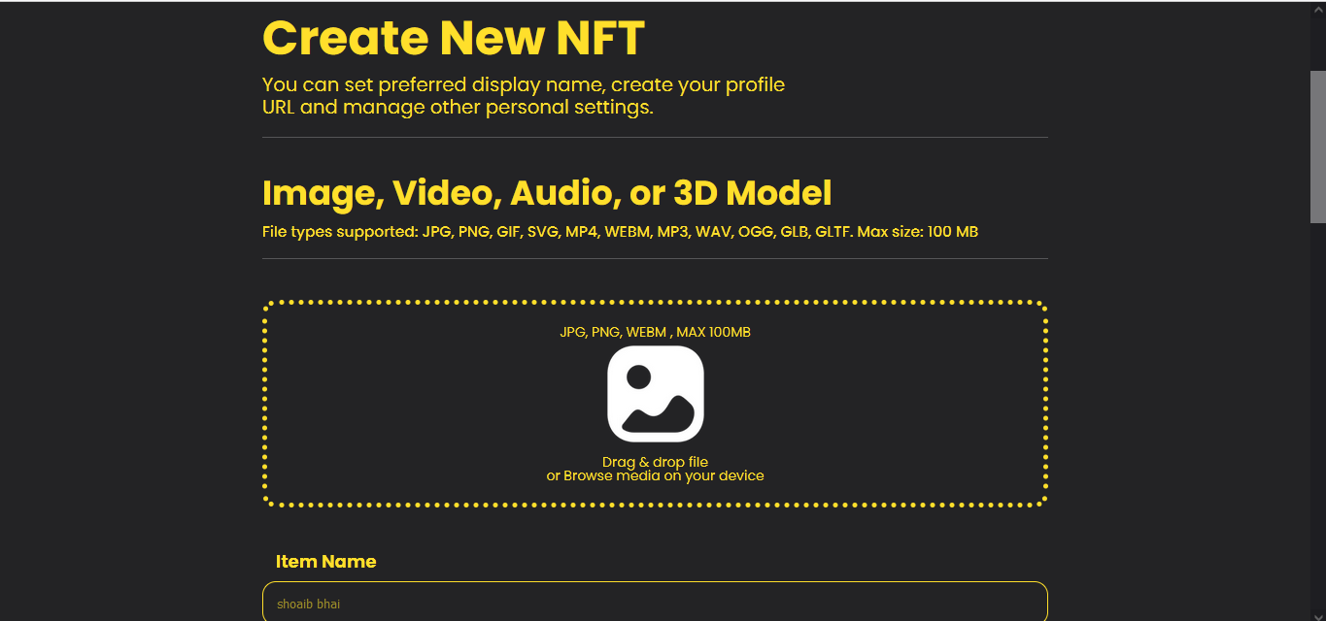

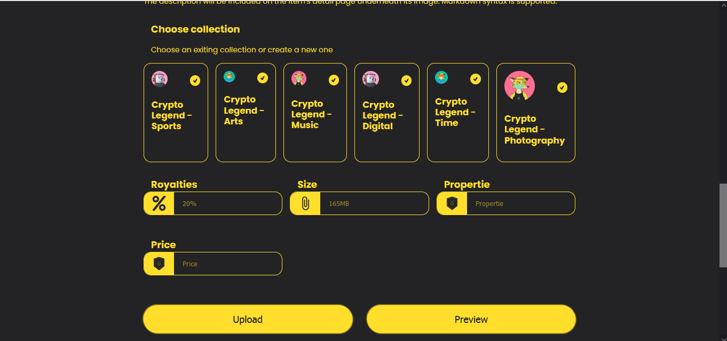

**Reference**

* Ethereum documentation :- <https://ethereum.org/en/developers/docs/>
* Code Eater - YouTube. <https://youtu.be/aFI_XPll_mg>
* Metamask wallet :- <https://metamask.io/>